

**ENGLISH COMPONENT – CYCLE 4 SESSION 4**

**ANDROID INTENTS**

**WORKSHEET 4.4**

**Worksheet 4.4.1**

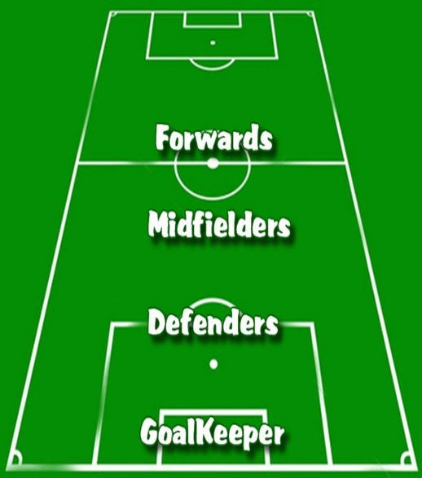**Let's talk about soccer!**

**Order the following description of how a soccer game works.**

The ball finds its way to the midfielders. **[ 3 ]**

The ball is passed from the goalkeeper to their defenders. **[1 ]**

One of the forwards sends the ball into the net of the opponent. **[4 ]**

The defenders pass the ball to the midfielders. **[2 ]**

**Worksheet 4.4.2**

**Vocabulary**

**Choose the right synonym for each of the new words.**

1. **To request :ask for,to inquire**
   1. To prohibit
   2. To make a petition
2. **Isolated:apart,separated,lonely,alone /aislamiento**
   1. Connected
   2. Not connected
3. **To handle:deal with**
   1. To manage
   2. To help
4. **Without:not included,the lack of something**
   1. Including
   2. Excluding
5. **Target :goal,aim,purpose**
   1. Objective
   2. Component
6. **To launch:release,deploy,initiate**
   1. To start
   2. To finish
7. **Snippet:fragment,particle,piece**
   1. A programmer
   2. A part of a code

**Worksheet 4.4.3**

**Vocabulary Practice**

**Read carefully the definitions and match them to the right word.**

|  |  |  |
| --- | --- | --- |
| 1.To request | 7__ | Is a programming term for a small region of re-usable [source code](https://en.wikipedia.org/wiki/Source_code), [machine code](https://en.wikipedia.org/wiki/Machine_code), or text |
| 2.To handle | **_1_** | The act of asking for something to be given or done. |
| 3. Isolated | **_5_** | An object, usually marked with ringed circles, to be aimed at in shooting practice or contests |
| 4. Without | **_6_** | To send forth, catapult, or release. |
| 5. Target | **_4_** | Not accompanied by. |
| 6. To launch | **_2_** | To manage, deal with, or be responsible for. |
| 7. Snippet | **_3_** | Separated from other persons or things. |

**Worksheet 4.4.4**

**Reading Comprehension Strategy - Summarizing**

**Watch the video “**[**How to write a summary - Educraft - YouTube**](https://www.youtube.com/watch?v=AEwmts9MqGs)**” and order the sentences:**

1. **___7__**skim the text to determine the main idea, look for the key words.
2. **___11___**start with an introductory sentence.
3. **__3____**improves your vocabulary as you use your own words to restate the passages meaning.
4. **____8__**if the text is too long, read the first and last paragraph.
5. **___1__**Learning to summarize improves your reading skills as you learn how to scan and skim a text.
6. **___4___**helps to develop critical thinking.
7. **___6___**Writing a summary consists of two steps: reading and writing.
8. **___13___**when you are done writing the summary, read it once more.
9. **__14____**check your spelling mistakes, make sure you have covered the important points.
10. ­**___9___**it’s only a paragraph long and it’s usually written in present or past tense.
11. **__2____**makes your reading faster so you can focus on the main points.
12. **___5___**It has the same meaning with the original text but in different and fewer words.
13. **___15_**leave out any examples mention by the author, avoid using questions or first person
14. **___10_**don’t copy, try to rephrase the author and don’t express your own opinion
15. **___12___** use the keywords that you found previously keeping the meaning of the original sentence.

**Worksheet 4.4.5**

**Reading**

**Read carefully the text and write down a short summary to show your comprehension of the text. Then share it on the Padlet so everybody can read it.**

**What Are Android Intents?**

Intents are a fundamental topic for Android developers. It is impossible to build Android applications without using intents.

**What are Intents?**

Imagine a football match: players pass the ball around the field with the objective of sending it into the goal of their opponent. The ball is passed from the team's goalkeeper to their defenders. Next, it finds its way to the midfielders, and

if things work out as planned, one of the forwards sends it into the net of the opponent. Great job!

In Android, the ability to send messages around is possible thanks to the Intent object. With the help of intents, Android components can **request** functionality from other Android components. When you open the Instagram app on your phone and use it to take a picture, you use an intent. Intents also help communicate between parts of an app; the movement from one screen (activity) to another is made possible by intents.

Look at it this way: all components (applications and screens) of the Android device are **isolated**. The only way they communicate with each other is with the help of intents.

**Starting Activities With Intents**

As mentioned earlier, you can use intents to start different components: activities, services, etc.

To start an activity, you will make use of the method start Activity(intent).

Here is a **code snippet** that demonstrates how to start another activity from an intent.

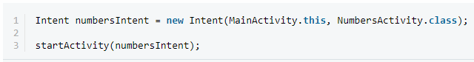

First, we create a new Intent object and pass it the Numbers Activity class. Then we start a new activity using that intent.

**Types of Intents**

Android supports two types of intents: explicit and implicit. We use explicit intents when we explicitly name the class of the target activity that will **handle** the intent. Implicit intents are used **without** a class name, where Android will help determine an appropriate Activity to handle the intent.

**Explicit Intent Example**

The code snippet of code above is an example of explicit intent. Have a look at it again.



Here, NumbersActivity is the **target** component from our MainActivity. This means that NumbersActivity is the defined component that will be called by the Android system. It is important to note (as in the example above), that explicit intents are typically used within an application, because that gives the developer the most control over which class will be **launched**.

**Implicit Intent Example**

Here's an implicit intent:



If you have the above code in your codebase, your application can start a browser component for a certain URL via an intent.

**Worksheet 4.4.6**

**Wrap-up**

**Reading Comprehension**

**Read the sentences below and then match the beginning of the sentence with its end.**

|  |  |  |
| --- | --- | --- |
| 1. All components of the Android … | **_3__** | 1. … do not have the class name defined. |
| 1. Explicit intents … | **_1__** | 1. … are isolated. |
| 1. Implicit intents … | **__4_** | 1. … to start different components of Android. |
| 1. You can use intents … | **_2__** | 1. … have the class of the target activity defined. |
| 1. Snippet is a … | **_5__** | 1. … small part of a re-usable code. |

**Worksheet 4.4.7**

**Wrap-up**

**Summarizing!**

Write down a short summary of the reading to share the most important aspects about the reading “Android Intents”, then post it on the Padlet the teacher created with this purpose.



**Worksheet 4.4.8**

**Self-evaluation**

**Complete the following self-evaluation section.**

1. Entiendo qué son “intents” en Android.

**Yes 😃 Maybe 😐 No 😟**

2. Entiendo la diferencia entre “explicit intents” y “implicit intents”.

**Yes 😃 Maybe 😐 No 😟**

3. Entiendo en qué consiste la estrategia de “summarizing”.

**Yes 😃 Maybe 😐 No 😟**

4. La estrategia “summarizing” me ayuda a entender mejor el texto que leo.

**Yes 😃 Maybe 😐 No 😟**